NEW TOEFL SET 7

READING SECTION

MODULE 1
Questions 1-10
Fill in the blanks.
The Mongol Empire became the largest continental land empire in history during the thirteenth century. Genghis Khan ¹uni_ _ _ _ the ²nom_ _ _ _ tribes and built a ³hig_ _ _ _ effective ⁴mili_ _ _ _ ⁵organi_ _ _ _ _ _. His armies ⁶conq_ _ _ _ _ vast ⁷terri_ _ _ _ _ _ stretching from Eastern Europe to the Pacific Ocean. The empire ⁸estab_ _ _ _ _ _ efficient trade ⁹rou_ _ _ ¹⁰th_ _ connected distant civilizations. When the empire eventually fragmented, it had permanently transformed political and cultural landscape across Asia.

Questions 11-12
Text Message Chain
Professor Adams – 2:15 P.M.
Just a reminder that your group presentations on renewable energy are due next Thursday. Please upload your slides to the course portal by 5:00 P.M. the day before.
Yuki Tanaka – 2:17 P.M.
Thanks for the reminder. Our group is meeting tonight to finalize everything.
Kevin Martinez – 2:19 P.M.
Yuki, I finished the section on wind energy. Should I send it to you now or wait until the meeting?
Yuki Tanaka – 2:21 P.M.
Go ahead and send it now. That way I can start integrating it with the other sections.
Amara Diallo – 2:23 P.M.
I'm almost done with the solar energy portion. I just need to add a few more statistics. I'll bring the completed version tonight.
Yuki Tanaka – 2:25 P.M.
Sounds good. Let's meet in the Library at 7:00 P.M. We can use one of the study rooms.

11. What will Mr. Martinez do?
A. Complete his section at the meeting
B. Send his work before the group meets
C. Help Ms. Diallo find statistics
D. Upload the slides to the portal
12. What can be inferred about Yuki Tanaka?
A. She is responsible for combining the group's work.
B. She has not started working on the presentation.
C. She prefers to work alone on group projects.
D. She is taking the course for the first time.

Questions 13-15
Read an email.
Subject: Photography Workshop Registration Confirmed
Dear Ms. Nakamura,

Thank you for registering for the Introduction to Digital Photography workshop. Your enrollment has been confirmed for the session beginning Saturday, March 15, at the Westfield Community Arts Center.

The workshop will run for four consecutive Saturdays from 10:00 A.M. to 1:00 P.M. Please bring your own digital camera; tripods and lighting equipment will be provided by the instructor. A materials fee of $35 is due on the first day of class.

Parking is available in the lot behind the building, and street parking is free on weekends. If you need to cancel your registration, please notify us at least 48 hours before the first session for a full refund.

We look forward to seeing you in class.

Sincerely,

David Kowalski

Program Coordinator

13. Why was this email sent to Ms. Nakamura?
A. To invite her to apply for an advanced photography course
B. To confirm her participation in an upcoming class
C. To notify her about a schedule change for the workshop
D. To request payment for previously completed sessions
14. What is Ms. Nakamura expected to bring to the workshop?
A. Her own photography equipment for taking pictures
B. A check for the materials fee on the first day
C. A tripod and portable lighting accessories
D. Examples of her previous photography work
15. What is NOT mentioned as being provided at the workshop?
A. Lighting equipment for photography exercises
B. Tripods for use during class sessions
C. Free parking behind the arts center
D. Printed instructional materials for students

Questions 16-20
Read a passage.
Social Conformity
People frequently adjust their opinions and behaviors to match those around them, even when doing so contradicts their own perceptions. This tendency toward conformity operates largely below conscious awareness and affects decisions ranging from consumer purchases to moral judgments. Understanding why individuals yield to group pressure reveals fundamental aspects of human social psychology.
Classic experiments by Solomon Asch demonstrated the power of conformity through a simple perceptual task. Participants judged which of three lines matched a standard line in length, an easy determination when made alone. When confederates unanimously gave obviously wrong answers, however, roughly thirty-five percent of participants conformed to the incorrect group response at least once during the trials. Follow-up interviews revealed that some participants genuinely doubted their own perception, while others knowingly gave wrong answers to avoid standing out. (A)
Cultural background shapes conformity rates in measurable ways. (B) Collectivist societies, which emphasize group harmony and interdependence, typically show higher conformity than individualist cultures that prize personal autonomy and self-expression. (C) Age also matters: adolescents conform to peers more readily than adults do, reflecting the developmental importance of social acceptance during that period. (D) These variations suggest that conformity serves adaptive functions whose expression depends heavily on social context.

16. The word “yield” in paragraph 1 is closest in meaning to
A. resist
B. give in
C. respond
D. contribute
17. What can be inferred about participants who gave incorrect answers in Asch’s experiments?
A. All of them genuinely believed the group was correct
B. Some prioritized social acceptance over accurate judgment
C. They were motivated primarily by fear of punishment
D. They had significant difficulty perceiving differences in line length

18. Why does the author mention Solomon Asch’s experiments in paragraph 2?
A. To prove that conformity is a relatively recent phenomenon in society
B. To argue that most psychological experiments produce unreliable results
C. To demonstrate how group pressure can influence individual judgment
D. To compare conformity rates between different age groups
19. According to the passage, which of the following is true about conformity?
A. Conformity rates are identical across all cultures worldwide
B. Adults conform to peer pressure more readily that adolescents do
C. Collectivist societies typically show higher conformity rates
D. Individualist cultures discourage all forms of group behavior

20. Look at the four letters (A, B, C, and D) in the passage that indicate where the following sentence could be added. Where would the sentence best fit?
“This finding has been replicated across numerous studies in different countries.”

A. Position A
B. Position B
C. Position C
D. Position D

Module 2
Questions 1-10
Fill in the blanks.
Clouds form when warm air rises and cools at higher altitudes. As ¹ t_ _ temperature drops, water vapor ² cond_ _ _ _ _ around tiny particles ³ cal_ _ _ condensation nuclei. Different cloud types ⁴ indi_ _ _ _ ⁵ var_ _ _ _ atmospheric conditions and ⁶ c_ _ help predict ⁷ upco_ _ _ _ weather patterns. Cumulus clouds ⁸ typi_ _ _ _ _ signal fair weather, ⁹ wh_ _ _ dark cumulonimbus formations often bring ¹⁰ thunde_ _ _ _ _ _ _. Meteorologists study these patterns carefully because accurate weather prediction remains essential for many human activities.
Questions 11-12
Read an Email
Subject: Tennis Court Reservation Confirmed
Dear Mr. Fitzgerald,
Your reservation for Court 3 at Lakewood Sports Center is confirmed for Sunday, June 8 from 2:00 PM to 4:00 PM. Please check in the front desk 10 minutes before your session. Rackets are available for rent, but players must bring their own tennis balls.

Best regards,
Nina Castillo
Facility Coordinator

11. What time should Mr. Fitzgerald check in?
A. 1:30 PM
B. 2:10 PM
C. 2:00 PM
D. 1:50 PM
12. What is Mr. Fitzgerald required to bring?
A. A valid membership card
B. Athletic footwear
C. Tennis balls
D. A tennis racket

Questions 13-15
Read a Notice
Community Volunteer Training Program Registration
The Maplewood Community Center is accepting applications for its annual volunteer training program. The three-day training will be held from March 14th to 16th at the Main Hall, and all sessions run from 9:00 A.M to 4:00 P.M. Participants will receive instruction in event coordination, first aid basics, conflict resolution, and working with diverse community members. Those who complete all sessions will receive an official volunteer certification valid for two years. Registration is free, but space is limited to 40 participants. Priority will be given to applicants who have not previously completed the program. Applications must be submitted by Friday, February 28th, either online at maplewood.org/volunteer or in person at the reception desk.
Lunch and refreshments will be provided on all three days. Participants are responsible for their own transportation. Please note that attendance at all three sessions is required to receive certification.
For more information, contact Program Coordinator Sarah Mendez at 555-0892
13. What is the main purpose of the notice?
A. To share information about how to enroll in the program
B. To recognize outstanding community volunteers
C. To request donations for community events
D. To explain new volunteer scheduling policies
14. What will happen if a participant misses one of the training sessions?
A. They will need to pay an additional fee
B. They will be placed on a waiting list
C. They will not receive certification
D. They will need to retake the entire program
15. What can be inferred about the volunteer training program?
A. It is being offered for the first time this year.
B. It has been conducted in previous years.
C. It is designed for experienced volunteers only.
D. It requires participants to have first aid experience.

LISTENING SECTION
MODULE 1
Questions 1-8

Listen to the question and select the best response from the choices.

1. A. The cleaner did a great job.
B. I’m thinking of getting a pet.
C. I closed the window earlier.
D. At six, I believe.

2. A. The fix was implemented last month.
B. The sunset was beautiful yesterday.
C. I managed the team for two years.
D. Still working on it, actually.

3. A. The bookstore is across the street.
B. Have you tried resetting your credentials?
C. The database contains valuable information.
D. I had trouble sleeping last night.

4. A. Sure, is something wrong with yours?
B. I swapped my old phone.
C. The concert was sold out.
D. The desk drawer is stuck.

5. A. Go straight and turn right at the fountain.
B. I got a haircut yesterday.
C. The building has three floors.
D. The soup needs more salt.

6. A. She’s an excellent manager.
B. The best route is through downtown.
C. Try her direct extension.
D. I prefer tea in the morning.

7. A. I made some changes to the document.
B. The museum closes at five.
C. I was just about to.
D. The restaurant has great reviews.

8. A. I’ll pick it up myself.
B. My bike needs new tires.
C. The delivery arrived damaged.
D. I picked up a cold last week.

Questions 9-10
Listen to a conversation.

9. What change are the speakers discussing?
- New operating hours for the cafeteria
- A renovation and menu update
- An increase in seating capacity
- A new cafeteria location
10. What does the woman say is a disadvantage of the changes?
- The food quality has decreased.
- There are fewer vegetarian options.
- The cost has increased.
- The lines are much longer.

Questions 11-12
Listen to a conversation.

11. What’s the woman’s problem?
- She lost her student ID.
- She cannot access her room.
- She missed an important meeting.
- She forgot her breakfast in the room.
12. What will the woman probably do next?
- Wait for the resident advisor
- Go to the campus security office
- Return to the dining hall
- Call a locksmith service

Questions 13-14
Listen to an announcement.

13. What is the main purpose of the announcement?
- To remind the students to return borrowed equipment
- To inform students about access card replacement
- To announce stricter entry requirements for buildings
- To explain a change in building security hours
14. What should students do according to the announcement?
- Update their contact information online
- Request permission from their academic advisor
- Return their old cards by mail
- Collect new cards from the Security Office

Questions 15-16
Listen to an announcement.

15. Which of the following is true about the Data Science Bootcamp?
- Participants must have previous programming knowledge
- The program spans six weekends in January
- Only computer science majors may enroll
- Classes will be taught exclusively by professors

- What will participants gain from the program?
- A guaranteed internship at a tech company
- College credit toward their degree
- Hands-on project experience and industry feedback
- Free software licenses for one year

Questions 17-20
Listen to a talk.
- What is the main topic of the talk?

- Why humans are more intelligent than other primates
- Nutritional requirements for brain health
- How the prefrontal cortex controls behavior
- The evolutionary development of the human brain

- According to the speaker, what contributed to the increase in brain size?

- Consumption of more nutrient-rich foods
- Living in colder climates
- Decreased need for physical activity
- Competition with other human species

- What does the speaker imply about the prefrontal cortex?

- It was the first brain region to evolve
- It is smaller in humans than in other primates
- It is responsible for higher- level cognitive functions
- It stops developing during childhood

- According to the speaker, brain size alone does NOT determine intelligence because:
- Modern humans have smaller brains than ancestors
- Neural organization and connections also play important roles
- Intelligence cannot be measured scientifically
- All mammals have similar brain size

Module 2
Questions 1-3

Listen to the question and select the best response from the choices.

- A. You might need to get it reactivated.
B. I worked overtime last week.
C. The hiking trail is closed.
D. The entrance has been repainted.

2. A. The director made that decision.
B. Sarah’s been appointed interim.
C. I’ll take the highway instead.
D. The flowers need watering.

3. A. Actually, I think you are.
B. My phone battery is low.
C. I presented the idea last month.
D. The first draft needs work.

Questions 4-5
Listen to a conversation.

4. What are the speakers mainly discussing?
A. A new research methodology
B. Completing a grant proposal
C. A professor’s recent feedback
D. An upcoming formatting workshop
5. What will the woman help with?
A. Editing the methodology section
B. Contacting the funding agency
C. Reviewing the research design
D. Formatting the final document
Questions 6-7
Listen to a conversation.

6. What are the speakers mainly discussing?
A. A product launch event
B. A mobile application update
C. Progress on website project
D. A new development team
7. What was previously a problem with the project?
A. The budget exceeded expectations.
B. The mobile version had issues.
C. The launch date was moved up.
D. The homepage design was rejected.

Questions 8-11
Listen to a talk.

8. What is the main topic of the talk?
A. How central banks control the company
B. The relationships between oil prices and transportation
C. Why saving money is important
D. The definition and cause of inflation

9. According to the speaker, what happens during demand-pull inflation?
A. Production costs increase significantly
B. Central banks raise interest rates immediately
C. Excess money in circulation drives prices up
D. Consumers stop purchasing goods entirely

10. Why does the speaker mention the price of oil?
A. To explain how cost-push inflation works
B. To argue that energy should be regulated
C. To compare different types of fuel
D. To show why transportation is expensive
11. What can be inferred about moderate inflation?
A. It is always harmful to economic growth
B. It is considered normal and even beneficial
C. It only affects wealthy individuals
D. It cannot be controlled by any institution

Questions 12-15
Listen to a talk.
12. What is the main topic of the talk?
A. How sleep affects memory and learning
B. Different stages of the sleep cycle
C. Why students should avoid studying at night
D. The cause of sleep disorders

13. According to the speaker, what happens in the brain during deep sleep?
A. The brain becomes completely inactive
B. The brain processes and organizes information
C. New information enters the brain
D. Memory is permanently erased

14. Why does the speaker mention a librarian sorting books?
A. To illustrate how the brain organizes information during sleep
B. To suggest that students should study in library environments
C. To explain why reading before bed can improve sleep quality
D. To compare different approaches to learning new material
15. What is implied about cramming before exams?
A. It is one of the most effective methods for exam preparation
B. It helps students cover more material in a shorter time period
C. It may prevent the brain from properly retaining information
D. It has little to no measurable effect on actual test performance

WRITING SECTION
Build a sentence
Questions 1-10
Make an appropriate sentence.

- Did you talk to the hotel about early check-in?

They _____ _____ _____ _____ _____ _____ _____.

what to know would arrive wanted time we

- I signed up for the charity run next month.

_____ _____ know ______ _______ ______ ________ ______?

do kilometers knowing how you many to run you have

- What did your landlord say about renewing the lease?

__________ _________ ___________ __________ ___________ __________ __________ for __________ ___________ year.

She asked to stay whether I was planning for another at least year.

- You look exhausted today.

I __________ ___________ __________ ___________ __________ ___________ __________ ___________ __________.

rewrote rewriting the entire up ended up late stayed I because report

- I am not sure about the dress code.

___________ __________ ___________ _________ ____________ _________ __________?

if was it did they formal say

- How did the interview with the new candidate go?

___________ ___________ us __________ ___________ __________ __________ ___________ before.

she impressed impressing she with the projects had led that

- I want to improve my public speaking skills.

Have ___________ __________ ___________ ___________ __________ __________ ________?

learning presentations your breathing during learned to control how you

- I thought the package was supposed to arrive today.

___________ __________ not ___________ yet?

come coming has it

What did the customer service representative say?

___________ asked __________ ___________ __________ ___________ __________ ___________ __________ .
the problem had me first I she noticed when

Where is everyone going after the meeting?

___________ __________ supposed ___________ __________ ___________ __________?
to meet we room supposing are in the conference

WRITE AN EMAIL
View Task Info
To: Parks Department Director
Subject: Concern About Park Maintenance
Situation:
You frequently visit a public park in your neighborhood for exercise and relaxation. Recently, you have noticed that several benches are broken, trash bins are overflowing, and the walking paths are in poor condition. You want to bring this to the attention of the city parks department.
Your email should:
- Describe the issues you have observed in the park
- Explain why it is important to address these issues
- Make a suggestion for how to deal with the situation

WRITE for an ACADEMIC DISCUSSION
View Task Info
Professor Nelson – Communication Studies
Today, let’s discuss whether social media does more harm than good. Some argue that social media can lead to issues like addiction, mental health problems, and the spread of misinformation. Others believe it helps people stay connected, share ideas, and raise awareness about important issues. What’s your perspective—does social media cause more harm than good?
Tina
I think social media does more harm than good. It can be highly addictive, with people spending hours scrolling through posts and comparing themselves to others. This constant comparison can lead to anxiety, depression, and feelings of inadequacy, especially among teenagers. Additionally, the spread of misinformation is a huge problem. False news spreads quickly on social media, and it’s often hard to distinguish between credible and unreliable sources.
Rick
I disagree. While social media has its downsides, I believe it does more good overall. It allows people to stay connected, especially with friends and family who live far away. Social media is also an effective tool for raising awareness about social issues and sharing important information quickly. During emergencies or crises, platforms like Twitter or Facebook can provide real-time updates that are crucial for public safety.

SPEAKING SECTION

Task 1
Listen and Repeat

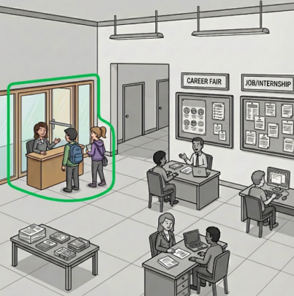



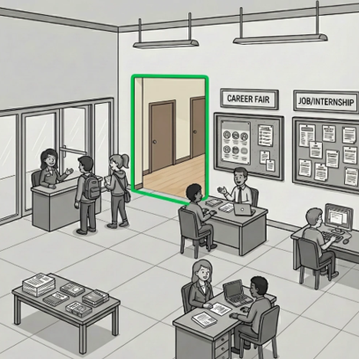
3.

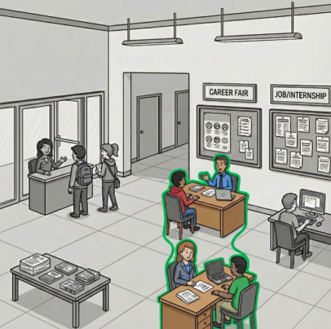
4.

5.
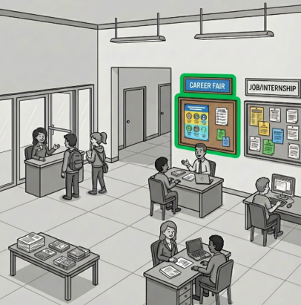

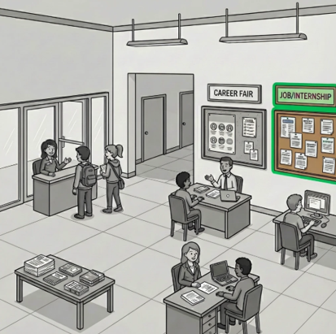
6.


7.

Task 2

Answer the interviewer’s questions.



